|  |  |
| --- | --- |
| **(Confidential)** | |
| Scope of disclosure | [TSDV, TCS] for TSDV, TCS only |
| Period of confidentiality | 7 years after published date |
| Head of Information Owner | Head of Engineering Dept. |
| Handling restriction | NA |

**Investigation Report**

**Network System Overview**

**Toshiba Software Development (Vietnam) Co., Ltd.**

|  |
| --- |
| Document ID: TSDV-TZCS-Investigation Monitor Mode |
| Total: 20 Page No. 1 |

Revision History

|  |  |  |  |  |  |  |
| --- | --- | --- | --- | --- | --- | --- |
| Rev. No.  (X.YY) | Date  (YY-MM-DD) | Section No. Changed | Change Description | Author | Reviewed by | Approved by |
| 0.01 | 2018-08-13 | All | Create document structure | HauND |  |  |
|  |  |  |  |  |  |  |

Table of Contents

1. Monitor Mode Summary 5

1.1. Monitor Mode of Indicator 5

1.2. Monitor Mode of Control Panel 6

2. Synchronizing Monitor Mode 7

2.1. Synchronizing Monitor Mode from Indicator to Control Panel 7

2.2. Synchronizing Monitor Mode from Control Panel to Indicator 7

3. Extend Monitor Function Proposal 8

3.1. Add More Monitor Mode to Indicator 8

3.1.1. Advantages 8

3.1.2. Disadvantages 8

3.2. Only Synchronizing Monitor mode 8

3.2.1. Advantages 8

3.2.2. Disadvantages 8

3.3. Conclude 8

4. GUI Appendix 9

4.1. Display Setting screen of Control Panel 9

4.2. Setting Monitor Mode on Control panel 10

4.2.1. Only Display1 Mode 10

4.2.2. Only Display2 Mode 11

4.2.3. Mirror Display Mode 12

4.2.4. Extend Right Mode 13

4.2.5. Extend Left Mode 14

4.2.6. Extend Below Mode 15

4.2.7. Extend Above Mode 16

4.2.8. Switch Right Mode 17

4.2.9. Switch Left Mode 18

4.2.10. Switch Below Mode 19

4.2.11. Switch Above Mode 20

**List of Tables**

Table 1-1: Indicator Behavior Table 5

Table 1-2: Control Panel Behavior Table 6

Table 2-1: Synchronizing Monitor Mode of Control Panel 7

Table 2-2: Synchronizing Monitor Mode of Indicator 7

Table 4-1: Setting Monitor Table 9

**List of Figures**

Figure 4‑1: Display Setting Screen 9

Figure 4‑2: Only Display1 Figure 10

Figure 4‑3: Only Display2 Figure 11

Figure 4‑4: Mirror Display Figure 12

Figure 4‑5: Extend-Right Figure 13

Figure 4‑6: Extend-Left Figure 14

Figure 4‑7: Extend-Below Figure 15

Figure 4‑8: Extend Above Figure 16

Figure 4‑9: Switch-Right Figure 17

Figure 4‑10: Switch-Left Figure 18

Figure 4‑11: Switch-Below Figure 19

Figure 4‑12: Switch-Above Figure 20

# Typical network components

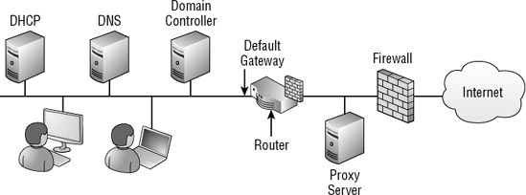

Figure 1‑1: Typical network components

- DHCP: A Dynamic Host Configuration Protocol (DHCP) server issues TCP/IP configuration information to users. This includes an IP address, subnet mask, address of the DNS server, address of the default gateway, and more.

- DNS: The primary purpose of the Domain Name System (DNS) server is to resolve hostnames to IP addresses. The client sends the name of a host on the network, and the server responds with the IP address.

- Domain Controller: A domain controller (DC) hosts Active Directory Domain Services (AD DS). AD DS holds objects (such as users, computers, and groups) that can be centrally managed and administered. Users and computers must have an account in AD DS to be able to log on to the domain and use domain resources. DNS is required for clients to locate DCs on the network.

- Default Gateway: A default gateway identifies the default path out of the subnet. All of the computers in the drawing to the left of the default gateway are on the same subnet, and their path to the Internet is through the default gateway. The default gateway is also referred to as the near side of a router, and it is specifically identified by the IP address assigned to the network interface connected to the subnet.

- Router: A router is a hardware device that routes data from one subnet to another. The router in the diagram has two network interfaces; one is the default gateway for the Internet network, and the other is the connection to the DMZ. A router is often assigned the first hostname in a network. This isn't required, but this standard is often followed in many networks. As an example, if the network ID is 192.168.1.0 (with a subnet mask of 255.255.255.0), the default gateway is often assigned 192.168.1.1.

- Firewall: A firewall is designed to filter traffic so that only specific traffic is allowed into or out of a network. A firewall starts with basic router-filtering capabilities but can be much more sophisticated in how the traffic can be examined and filtered. The two firewalls shown in the diagram (to the left and right of the proxy server) are a combination of hardware and software. Host-based firewalls can be installed on any system and are referred to as software-based firewalls.

- Proxy Server: A proxy server can be used to access Internet resources. When it's used in a network, all clients would be configured to submit Internet requests to the proxy server, and the proxy server would then request the data from the Internet.

IP traffic travels from host to host in networks using unicast, multicast, or broadcast methods.

Unicast Data travels from one computer to another computer. A unicast message will be processed only by the host with the destination IP address.

Multicast Data travels from one computer to multiple computers. This was mentioned and stressed as one of the benefits of Windows Deployment Services (WDS). WDS is able to multicast a single image to multiple computers at the same time. In contrast, if WDS did this as unicast, it would have to send a separate copy of the image over the network for each client.

Broadcast Data travels from one computer to all computers in the subnet. Each computer that receives the packet will process it and determine whether it needs to take action with the packet. Broadcast traffic is not passed through the router.

## Identifying Misconfigured Clients

All assigned IP addresses within a single subnet must have the same network ID. If not, they will not be able to communicate with other clients on the subnet. In addition, each client must be configured with the correct default gateway or it will not be able to communicate outside the network.

Consider Figure 6. Each client (numbered 1 through 6) has an assigned IP address (IP), subnet mask (SM), and default gateway (DG).

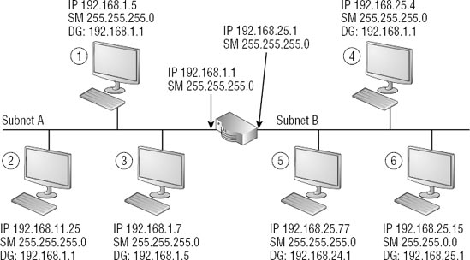

# Synchronizing Monitor Mode

This section describes how to synchronize monitor mode between Indicator and Control Panel.

# Extend Monitor Function Proposal

In this section we just list our method we can implement:

1. Add all switching monitor types of Control Panel to Indicator.
2. Only synchronize status between Control Panel and Indicator status.

# GUI Appendix

This section contains images that support user clear about Display Setting options of Control Panel and all monitor modes of Control Panel.